
Crawdad 2026
Centering Resonance Analysis of Text
User’s Manual · Version 1.4.7 · built 2026-08-09
Please cite: Corman, S., Kuhn, T., McPhee, R., & Dooley, K. (2002). Studying complex discursive systems: Centering Resonance Analysis of organizational communication. Human Communication Research, 28(2), 157–206.
Dooley, K. (2026). Crawdad Text Analysis Software (Version 1.4.7) [Computer software].
Disclaimer: analyses are generated automatically and provided as-is, without warranty of any kind. We take no responsibility for interpretations, conclusions, or decisions based on these results; verifying fitness for any particular use is the responsibility of the user.

Contents
1. Introduction 4
2. Installation and Verification 4
2.1 Requirements 4
2.2 Installing 4
2.3 Verifying your copy 4
3. Quick Start 5
4. The Generator 5
4.1 Input files 5
4.2 Optional tokenization file 5
4.3 Settings 5
4.4 Batch mode 6
4.5 Results table 6
5. Understanding the CRA File (_cra.md) 6
6. Text Metrics Reference 6
Full references 8
7. The Analyze Screen 9
8. Visualizer 9
9. Comparator 9
10. Classifier 10
10.1 How K is chosen 10
10.2 Reading and exploring the output 10
10.3 Interactive hierarchical clustering (dendrogram) 10
11. Theme Identifier 11
12. Latent Theme Identifier 11
13. Summarizer 11
14. Methodological Notes and Reproducibility 11
15. Troubleshooting 12
Interpreting your output: a worked example 13
Reading the Visualizer image 13
Reading the Summarizer text-profiles table 14
Reading the most-influential-words table 14
Reading the Theme Identifier output 15
Putting it together 16
Appendix A. File Format Quick Reference 17
A.1 Tokenization file (.csv / .xlsx) 17
A.2 Latent codes file (.csv / .xlsx) 17
A.3 Outputs 17

1. Introduction
Crawdad 2026 analyzes the conceptual structure of texts using Centering Resonance Analysis (CRA), the network text analysis method developed by Corman, Kuhn, McPhee, and Dooley (2002). Instead of counting words, CRA represents a text as a network: the nouns and adjectives that authors deploy in noun phrases become nodes, words linked in the flow of discourse become edges, and a word’s influence is its structural importance in holding that network together (its betweenness centrality). Influential words are the ones doing the organizing work of the text’s coherence — which is not the same as the most frequent ones.
From that representation, Crawdad answers practical research questions: What is this text about? How similar in meaning are two texts? How does a collection of texts cluster? What themes run through a corpus? How do texts score against my own coding categories? It also profiles each text on fourteen standard text-level metrics (sentiment, readability, formality, lexical diversity, and more).
The application runs entirely in your web browser. Nothing is installed, no account is needed, and no data ever leaves your computer. It works identically on Mac, Windows, and Linux, online or offline.
Citing. All output files carry the required citation: Corman, S., Kuhn, T., McPhee, R., & Dooley, K. (2002). Studying complex discursive systems: Centering Resonance Analysis of organizational communication. Human Communication Research, 28(2), 157–206.

2. Installation and Verification

2.1 Requirements
- Any modern browser: Chrome, Edge, Firefox, or Safari (Internet Explorer is not supported).
- No internet connection required. No installation, no administrator rights.

2.2 Installing
- Unzip the Crawdad distribution (e.g., Crawdad-app-v1.2.2.zip) anywhere on your computer.
- Open the folder and double-click index.html. The app opens in your default browser.
On Windows, if the zip came from email or the web, right-click it and choose “Extract All” first. Because nothing is installed or executed outside the browser, no security warnings should appear.

2.3 Verifying your copy
- Open tests/index.html and click through the test suites — every page should show all green PASS lines (137 automated checks covering the mathematics, the parser, and the file formats).
- The file CHECKSUMS.txt lists a SHA-256 hash for every file. On a Mac, run shasum -a 256 -c CHECKSUMS.txt in Terminal from inside the folder; every line should say OK.
- See SECURITY-AND-PROVENANCE.md for the app’s security properties (no network access, no storage, no telemetry) and the licenses of the bundled open-source libraries.

3. Quick Start
- Open the app and choose Generate new CRA file(s).
- Drag one or more text files (.txt, .md, .pdf, .docx) onto the drop zone.
- Click Run Generator. Each text becomes a CRA network file (filename_cra.md) listing its most influential words, network statistics, and text metrics.
- Click Send selected to Analyze to load the results, then pick an analysis: Visualizer, Comparator, Classifier, Theme Identifier, Latent Theme Identifier, or Summarizer.
- Or check Batch mode before running: Crawdad will generate, visualize, classify, find themes, summarize, and download every output automatically.

4. The Generator
The Generator turns raw texts into CRA network files. It is the only step that reads your original documents; every other module works from the generated files.

4.1 Input files
- .txt and .md — used as-is.
- .pdf and .docx — converted to text in your browser. Scanned (image-only) PDFs have no extractable text; Crawdad detects this and warns rather than producing an empty analysis. Converted files offer a “download .md” link so you can inspect the extraction.
Cleaning is automatic and logged: repeated running headers/footers, bare page numbers, markdown/HTML markup, line-break hyphenation, “et al.” fragments, parenthetical citations containing a year (e.g., “(Grosz, Weinstein, & Joshi, 1995)”), numbered bracket citations (e.g., “[12]”), DOIs, and bare URLs are removed so that citation artifacts do not become network nodes. A trailing reference list is also removed: a heading such as “References”, “Bibliography”, or “Works Cited” in the later part of a document drops everything from that heading to the end (an Appendix that follows it is kept) — otherwise author surnames and journal abbreviations flood the network with spurious nodes. The processing log under the Results table and the “Text cleaning” section of each output file report exactly what was removed from each file.

4.2 Optional tokenization file
A spreadsheet (.csv or .xlsx, no header row): column 1 is the text to find, column 2 the replacement — e.g., “supply chain management” → “SCM” or “supply_chain_management”. Substitutions are applied before parsing, case-insensitively, longest match first, on whole words. Use this to protect multi-word terms of art from being split. The replacement must be a single token: use an acronym or join the words with underscores; the joined form appears verbatim as one node and is never stemmed. (Versions before 1.4.7 silently split underscore replacements back into separate words during parsing; this is fixed.) Matching is whole-word, so add inflected variants (“supply chains”) as separate rows. To help you build this file, every generated output ends with a “Tokenization suggestions” section listing word pairs and triples that repeatedly occur adjacent within the same noun phrase; these are frequency-based candidates only — whether a phrase is genuinely one concept is your judgment. Add the rows you accept to a tokenization file and re-run the Generator.

4.3 Settings
Setting | Default | Notes
Stemming | Porter | Matches the post-2002 Crawdad product. “Minimal plural only” reproduces the 2002 paper (JHC) behavior; “None” disables stemming.
Retain pronouns | Off | CRA drops pronouns by default (JHC p. 175). Turn on when actor reference matters to your question.
Inter-sentence linking | Off | Off by default (strict JHC 2002 replication). Check to link the last concept of each sentence to the first of the next (post-2002 product behavior).
Exclude words | (empty) | Comma-separated words that never become network nodes and break phrase runs like verbs. Use when the tagger mis-labels a verb as a noun (e.g., “chased”). Recorded in the output’s parameters.
Important: files generated with different settings are not strictly comparable. The Comparator warns when two files’ settings differ; keep settings constant within a study.

4.4 Batch mode
Check Batch mode before Run Generator to execute the full pipeline in one click: generate all CRA files, render a network PNG for every file, run the Classifier and Theme Identifier (when 5+ files) and the Summarizer (2+ files), and download every output. Your browser will ask once for permission to download multiple files. Progress and any skipped stages are reported next to the Run button.

4.5 Results table
Each processed file shows its node and edge counts and its five most influential words — a quick face-validity check before deeper analysis. Use the checkboxes with Send selected to Analyze or Download selected for bulk handling.

5. Understanding the CRA File (_cra.md)
One file is produced per text. It is a plain-text markdown document you can read, print, or archive, with four parts:
- Header — source file, processing date, app version, and the exact settings used (your reproducibility record).
- Network summary — node and edge counts; degree, betweenness, closeness, and eigenvector centralization; mean influence; and fragmentation (number of connected components and the share of words in the largest — coherent texts yield one dominant component).
- Influential words — every word with influence above 0.005, sorted by influence, with its degree and its network neighbors. Influence is normalized betweenness centrality (0–1): the share of shortest paths between other word pairs that pass through this word. The 0.005 threshold affects display only; all computations use the complete network.
- Text metrics — the fourteen document-level measurements described in Section 6, each with a plain-language interpretation column.
- Text cleaning — what the deterministic cleaner removed before parsing (reference list, citations, DOIs, headers/footers), so you can audit that nothing substantive was dropped. Present only when something was removed.
- Tokenization suggestions — word pairs and triples that repeatedly occur adjacent within the same noun phrase, with a ready-to-paste single-token replacement for a tokenization file (Section 4.2). Candidates only; accepting one is an analytic judgment.
- Data block — a machine-readable JSON section holding the complete network. Analysis modules read only this block. Do not edit it; a damaged block makes the file invalid (the Analyze screen will say why).

6. Text Metrics Reference
Metrics marked HEURISTIC use transparent rule- or marker-based approximations because no validated public instrument exists (or the research-grade norms could not be bundled); interpret those comparatively across texts rather than as absolute values. From version 1.4.7 the metrics table in each output also carries an Interpretation column that places each value in a labeled band (e.g., “dense, information-packed (academic register)”). The bands follow the cited source where one exists and are otherwise rough conventions — descriptive guides, not validated cutpoints; comparisons across texts processed with identical settings remain more defensible than absolute readings.
Metric | Scale | Method | Reading it
Sentiment | −1 to +1 | AFINN-165 word list (Nielsen 2011), mean valence per sentence, rescaled from ±5 | Mean tone of sentiment-bearing words; a mostly neutral text with one glowing sentence can still score high.
Gendered language | −1 to +1 | Agentic vs. communal stems (Gaucher, Friesen, & Kay 2011) | +1 all masculine-coded, −1 all feminine-coded; rates per 1,000 words also shown.
Abstractness | 0 to 1 | HEURISTIC: share of nouns with abstract suffixes (-tion, -ness, -ity…) | Higher = more abstract; for research-grade use see Brysbaert et al. (2014) norms.
Agreeableness | −1 to +1 | HEURISTIC: agreement vs. disagreement marker counts | +1 agreement-dominant, −1 disagreement-dominant.
Lexical diversity | MTLD; TTR | MTLD (McCarthy & Jarvis 2010); type-token ratio | MTLD is length-robust (higher = more varied vocabulary); TTR shown for reference only.
Lexical density | 0 to 1 | Content words / all words (Ure 1971) | Typical prose ≈ 0.4–0.6; higher = more information-dense.
Readability | FRE; grade | Flesch Reading Ease; Flesch–Kincaid grade (Kincaid et al. 1975) | FRE 60–70 = plain English; below 30 = very difficult (typical of journals).
Cohesion | 0 to 1 | Adjacent- and all-pairs sentence noun overlap (Coh-Metrix style; Graesser et al. 2004) | Share of sentence pairs sharing at least one noun; higher = tighter referential cohesion.
Certainty | −1 to +1 | Hedges vs. boosters (Hyland 2005) | +1 assertive/boosted, −1 hedged/tentative.
Pronoun rates | per 1,000 | Counted before CRA drops pronouns | I / we / you / third-person rates; useful for voice and stance.
Word length | chars; share | Mean characters; share of words ≥ 7 characters | Simple sophistication proxy.
Passive voice | 0 to 1 | HEURISTIC: be-verb + participle pattern | Share of sentences containing a passive construction.
Formality | ≈ 0–100 | F-score (Heylighen & Dewaele 1999) from part-of-speech mix | ≈50 neutral; higher = formal/nominal style, lower = involved/conversational.
Fragmentation | count; share | Connected components of the CRA network | Appears in the network summary; one dominant component indicates a coherent text.

Full references
Sources for each measure implemented in the Generator (also documented in the code). Metrics labeled “heuristic” in the output (abstractness, agreeableness) are unvalidated proxies with no external source and should be treated as exploratory.
Brysbaert, M., Warriner, A. B., & Kuperman, V. (2014). Concreteness ratings for 40 thousand generally known English word lemmas. Behavior Research Methods, 46(3), 904–911. [Research-grade alternative to the bundled abstractness heuristic.]
Corman, S. R., Kuhn, T., McPhee, R. D., & Dooley, K. J. (2002). Studying complex discursive systems: Centering Resonance Analysis of organizational communication. Human Communication Research, 28(2), 157–206. [Influence, resonance, and the CRA network model.]
Flesch, R. (1948). A new readability yardstick. Journal of Applied Psychology, 32(3), 221–233. [Flesch Reading Ease.]
Freeman, L. C. (1979). Centrality in social networks: Conceptual clarification. Social Networks, 1(3), 215–239. [Degree, betweenness, and closeness centralization.]
Gaucher, D., Friesen, J., & Kay, A. C. (2011). Evidence that gendered wording in job advertisements exists and sustains gender inequality. Journal of Personality and Social Psychology, 101(1), 109–128. [Masculine/feminine (agentic/communal) word lists for the gender index.]
Graesser, A. C., McNamara, D. S., Louwerse, M. M., & Cai, Z. (2004). Coh-Metrix: Analysis of text on cohesion and language. Behavior Research Methods, Instruments, & Computers, 36(2), 193–202. [Referential cohesion (adjacent and global noun overlap).]
Heylighen, F., & Dewaele, J.-M. (1999). Formality of language: Definition, measurement and behavioral determinants (Internal Report). Center “Leo Apostel”, Free University of Brussels. [Formality F-score.]
Hyland, K. (2005). Metadiscourse: Exploring interaction in writing. Continuum. [Hedge and booster lists for the certainty index.]
Kincaid, J. P., Fishburne, R. P., Rogers, R. L., & Chissom, B. S. (1975). Derivation of new readability formulas (Automated Readability Index, Fog Count and Flesch Reading Ease Formula) for Navy enlisted personnel (Research Branch Report 8-75). Naval Technical Training Command. [Flesch–Kincaid grade level.]
McCarthy, P. M., & Jarvis, S. (2010). MTLD, vocd-D, and HD-D: A validation study of sophisticated approaches to lexical diversity assessment. Behavior Research Methods, 42(2), 381–392. [MTLD lexical diversity.]
Nielsen, F. Å. (2011). A new ANEW: Evaluation of a word list for sentiment analysis in microblogs. In Proceedings of the ESWC2011 Workshop on ‘Making Sense of Microposts’ (pp. 93–98). arXiv, arXiv:1103.2903. [AFINN-165 sentiment lexicon, via wink-sentiment.]
Ure, J. (1971). Lexical density and register differentiation. In G. E. Perren & J. L. M. Trim (Eds.), Applications of linguistics (pp. 443–452). Cambridge University Press. [Lexical density.]

7. The Analyze Screen
Load one or more _cra.md files (drag-and-drop or click). Each file is validated against the Crawdad format on load; invalid files are flagged with the reason and excluded from analyses. Each analysis card states how many valid files it needs and activates automatically.
Session bundles. Save session bundle (.zip) packages every loaded file into one archive; Load session bundle restores it later or on another machine. This is the convenient way to keep a study’s files together.

8. Visualizer
Draws the CRA network in the style of the original Crawdad renderings: words sized by influence, a red box on the single most influential word, black boxes on words above the highlight threshold, and curved gray edges that darken and thicken with link strength.
- Words shown — top K by influence (default 30).
- Highlight threshold — default influence > 0.05 for the black boxes.
- Interaction — drag words to fine-tune the layout; hover for exact influence and degree.
- Export — Download PNG produces a 1920×1080 (16:9) image sized for a PowerPoint slide, with the filename, logo, and citation. Export all PNGs renders one image per loaded file.
Note: the force-directed layout is deterministic per drawing but is an approximation — node positions will differ from the 2002-era renderings even when the network is identical. What is comparable is the structure: who is boxed, sizes, and connections.

9. Comparator
Select texts A and B. Four resonance values are reported (equation numbers refer to the 2002 article):
Measure | Range | Meaning
WR (Eq. 2) | unbounded | Word resonance: shared words weighted by their influence in both texts. Grows with text size; compare only within similar-length texts.
WR′ (Eq. 3) | 0 to 1 | Standardized word resonance — the headline number. 1 = identical influence structure; 0 = no shared vocabulary.
PR (Eq. 5) | unbounded | Pair resonance: shared word pairs (co-occurrences), weighted by influence and frequency.
PR′ (Eq. 6) | 0 to 1 | Standardized pair resonance — stricter than WR′ because it requires the same words to be assembled the same way.
Below the numbers: up to 10 common words both texts rely on (ranked so that both texts must value the word), and up to 10 words unique to each text. The report warns if the two files were generated with different settings — such comparisons understate resonance. Resonance matches words after stemming; texts about the same topic in entirely different vocabulary will legitimately score low.

10. Classifier
Clusters five or more texts by their mutual word resonance (WR′). The method is K-means (with a fixed random seed — identical inputs always give identical clusters).

10.1 How K is chosen
Raw fit statistics often favor uninformative splits (for example, 8 texts vs. 1). Crawdad therefore targets K = √n and accepts it when its silhouette fit is within 0.10 of the best available; otherwise it falls back to the best-fitting K, preferring solutions without single-text clusters. The output states in plain language which rule fired, and flags any singleton cluster so you can judge whether it is a true outlier.

10.2 Reading and exploring the output
- Cluster membership with sizes, and the silhouette-by-K table (fit, sizes, singleton flags for every K tried).
- Change K after a run — via the selector or the “view” links in the table — to inspect alternative solutions instantly; the downloadable report always matches what you are viewing and records whether K was rule-selected or chosen manually.
- The MDS plot places texts in two dimensions (distance = 1 − WR′), colored by cluster.
- Cluster aggregation: when source texts were generated in this session, one click merges a cluster’s texts, re-runs the Generator, and produces a cluster-level _cra.md you can visualize.

10.3 Interactive hierarchical clustering (dendrogram)
Below the K-means results, Crawdad also builds a hierarchical agglomerative clustering (average linkage) of the same texts and draws it as a dendrogram: texts along the bottom, merge height (1 − WR′ distance) on the vertical axis — texts that merge low are highly resonant; branches that join high are dissimilar.
- Drag the red dashed bar up or down (or click at any height) to set the cut. Clusters recolor instantly, and K, cluster sizes, mean silhouette, and any singleton warning update live — explore the trade-off between fewer, coarser clusters (high cut) and more, finer ones (low cut).
- Membership table — lists each cluster’s texts at the current cut, color-matched to the dendrogram leaves.
- Report — the downloaded classification report captures whatever cut is set at download time (height, K, sizes, silhouette, membership) alongside the K-means solution.
K-means and the dendrogram may disagree; that is informative. Hierarchical clustering respects nested structure while K-means optimizes compactness — where they diverge, the dendrogram usually shows a text sitting between groups.

11. Theme Identifier
Finds manifest themes across five or more texts: the 50 words with the greatest summed influence across the corpus form a word-by-text matrix, and principal components analysis of the texts’ correlations extracts the themes.
- Components table — eigenvalues (highlighted when > 1.0, the conventional retention criterion) and each text’s loading on each component (highlighted when |loading| > 0.4). Loadings are bounded by 1.
- Varimax rotation — applied automatically to the eigenvalue > 1 components for simple structure, so each text and word loads on as few themes as possible. After rotation the variance column reads “SS loadings” rather than eigenvalues.
- Defining words — the top 10 words per theme by standardized word score (z-units, typically within ±3). These are not loadings; they identify which words define each theme’s poles.
With n texts there are at most n − 1 meaningful components: expect one or two interpretable themes from 5–6 texts, not a full factor structure.

12. Latent Theme Identifier
Scores texts against your own coding dictionary. Provide a spreadsheet (.csv or .xlsx): column 1 = theme name, column 2 = a word (one per row, or comma-separated). Code words are stemmed with the same setting as your files before matching.
The output is a theme × text table of summed influence, plus a coverage report: any code word that matched no text is listed by name. Check this list every run — a misspelled or unstemmed code word silently scores zero, which is a validity trap.

13. Summarizer
For two or more texts, the Summarizer produces:
- Text profiles — one row per text, 29 columns: nodes, edges, all network statistics, and every text metric. This table is a ready-made dataset (one observation per text) and is included machine-readably in the downloaded report for import into a statistics package.
- Most influential words — the top 50 words by summed influence across the corpus, with each word’s influence in every text.
Files generated before version 1.2 show a dash for metrics that did not yet exist; regenerate them to fill the columns.

14. Methodological Notes and Reproducibility
- Crawdad is fully deterministic: the same input files with the same settings produce byte-identical results, on any machine. There is no model, no randomness (clustering uses a fixed seed), and no network dependence.
- Stemming defaults to Porter (the post-2002 Crawdad product behavior); inter-sentence linking defaults to off (the 2002 article behavior). For fully article-faithful replication also set stemming to “Minimal plural only”. Version 1.4.6 · built 2026-08-03 completed a nine-component validation study: parsing scored against a 60-sentence hand-annotated gold corpus (F1 0.975), and all network, resonance, clustering, theme, and text-metric calculations verified against independent references (NetworkX, scikit-learn, SciPy, hand-worked examples).
- Every output records the settings that produced it. Keep settings constant within a study; regenerate rather than mixing files from different settings or versions.
- The parser (noun-phrase extraction) was benchmarked at F1 = 0.97 against a hand-annotated gold standard; its residual errors are missed modifiers, not lost head nouns. Betweenness, resonance, PCA, and varimax are each validated against hand calculations or independent reference implementations (see tests/index.html).
- When reporting results, cite: Corman, S., Kuhn, T., McPhee, R., & Dooley, K. (2002). Studying complex discursive systems: Centering Resonance Analysis of organizational communication. Human Communication Research, 28(2), 157–206.

15. Troubleshooting
Symptom | Remedy
A module’s Run button stays gray | Check the file-count requirement on the card and the Loaded files table — only files marked “valid” count. Invalid rows show the reason in red.
PDF yields almost no text | The PDF is a scan (image-only). Crawdad does not perform OCR; convert it externally or supply a text version.
Only the first download arrives in a batch | Allow multiple downloads when the browser asks (a one-time permission per site/folder).
App looks outdated after replacing files | Hard-refresh: Cmd+Shift+R (Mac) or Ctrl+F5 (Windows), or close and reopen index.html.
“No machine-readable JSON block found” | The _cra.md file was edited or truncated. Regenerate it from the source text.
Comparator warns about different parameters | The two files were generated with different stemming/linking settings. Regenerate both with the same settings before comparing.
Latent themes score zero everywhere | See the coverage report: your code words probably did not survive stemming or are misspelled. Edit the codes file and re-run.
An obviously spurious word ranks as influential | Inspect the processing log for that file. Add the artifact to a tokenization file mapping it to a correct term, or report it — the cleaning rules are extensible.
Some text-metric columns show a dash (—) in the Summarizer | Those _cra.md files were generated by an older app version, before those metrics existed. Hard-refresh the app, regenerate the files from their source texts, and the columns fill in. A dash is deliberate: Crawdad never fabricates values it did not compute.
A verb appears as a network node | Crawdad cross-checks two independent part-of-speech taggers and automatically corrects the most common error (past-tense “-ed” verbs mis-read as nouns). If an irregular verb still slips through, add it to “Exclude words” in Generator Settings and regenerate; the exclusion is recorded in the output for reproducibility.
All influence values are zero on a short test text | Usually a symptom of the mis-tagged-verb problem above: a stray “noun” can fuse a whole sentence into one phrase, producing a fully connected network — and in a fully connected network betweenness is legitimately zero for every word (no word mediates between any others). Exclude the mis-tagged word and regenerate. On genuinely tiny texts, zero influence for words at the ends of chains is correct behavior, not an error.

Interpreting your output: a worked example
This section walks through real output from a batch run of 26 Abraham Lincoln texts (1832–1865): the Lincoln–Douglas debate speeches of 1858, the major addresses of 1861–1865, annual messages to Congress, and several short letters and remarks. It shows how to read each table, and where the common over-readings are.

Reading the Visualizer image
The Visualizer draws the top-K most influential words (default 30) of one text. Word size scales with influence; a black box marks influence above the highlight threshold (default 0.05); a red box marks the single most influential word; darker, thicker edges mean word pairs linked more often. Below is the July 1861 message to Congress:
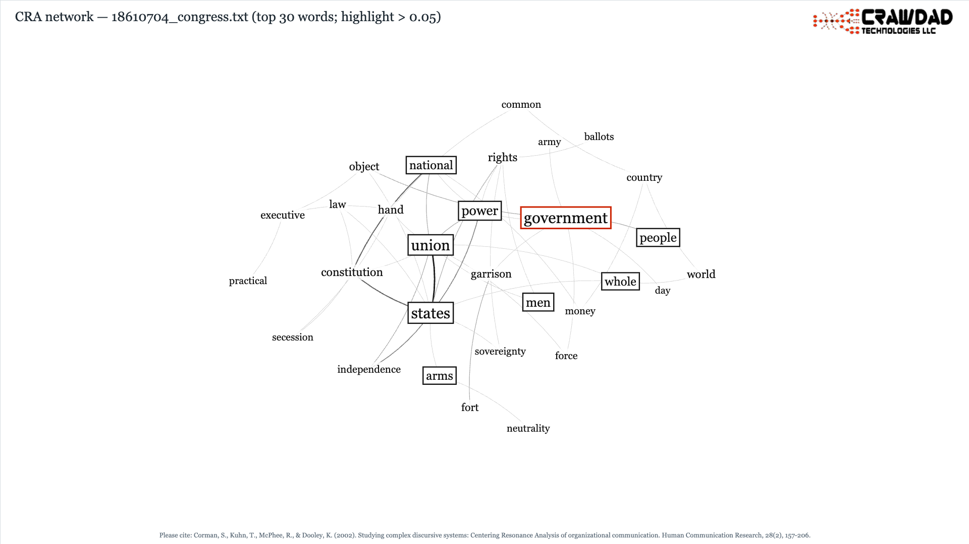
Visualizer export for 18610704_congress.txt (top 30 words; highlight > 0.05).
Reading it: “government” (red) is the structural hub of this text, bridged tightly to “states,” “union,” “power,” and “people” (black boxes). The unboxed periphery — “fort,” “garrison,” “neutrality,” “ballots” — shows the concrete subject matter those abstractions organize. Keep in mind that the image shows only the top-30 subnetwork. Influence was computed on the full network of 428 words, so a word missing from the picture is not necessarily unimportant; it just fell below the display cut.

Reading the Summarizer text-profiles table
The Summarizer produces one row per text with its network and text-level metrics. Three checks are worth making before interpreting anything.
1. Check text size first. Start with node count. The First Inaugural (1861) yields 464 nodes; the Gettysburg Address yields 50; short letters to General Grant yield 28–33. Metrics computed on tiny texts are unstable. One Grant letter shows an MTLD of 157 and a gender index of −1.0; that is small-sample noise, not evidence of anything. Treat texts under roughly 100 nodes as descriptive only, and be cautious comparing them against long texts.
2. Compare within a metric, not across metrics. Flesch Reading Ease in this corpus runs from 55.7 (1863 proclamation, dense legal language) to 85.0 (a short Grant letter). The absolute numbers matter less than the ordering. (In validation, rank-order proved reliable while absolute values shifted on jargon-heavy text.) The First Inaugural (62.5, FK grade 6.7) reads as measurably denser than the stump speeches of 1858 (74–79, grades 4–5), which matches what historians say about Lincoln adapting register to audience.
3. Watch the pronoun and certainty columns as rhetorical fingerprints. The 1861 message to Congress uses “I” about once per thousand words. The 1832 Sangamon County announcement, a personal campaign statement, uses it 62 times per thousand. The certainty index is negative for nearly every text (Lincoln hedged habitually) and swings positive only in the 1863 proclamation, written to leave no room for doubt.

Reading the most-influential-words table
Influence measures structural position in the word network (how often a word lies on the shortest paths between other words), not frequency. The table sums influence across all texts and shows each text’s contribution, which makes concentration patterns easy to see:
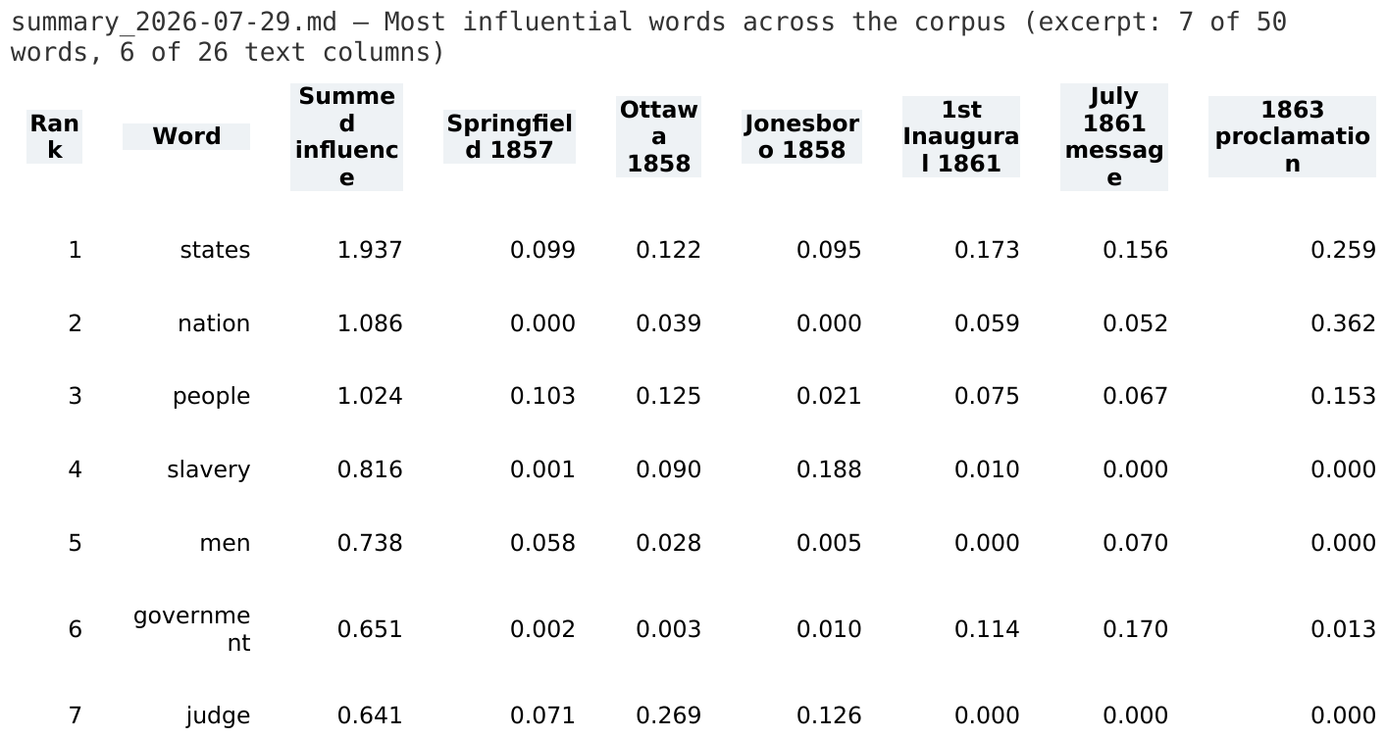
Excerpt from summary_2026-07-29.md: 7 of the top-50 words, 6 of 26 text columns.
• “states” (summed 1.94) is the top word overall and appears in nearly every text; it anchors the whole corpus.
• “judge” (0.64) is concentrated almost entirely in the 1858 debate speeches (0.27 at Ottawa alone, near zero elsewhere), reflecting Lincoln’s constant address of “Judge Douglas.” A word can rank high overall on the strength of one or two texts; always scan the per-text columns before calling something a corpus theme.
• Zeros are information. “slavery” scores 0.19 at Jonesboro in 1858 and exactly zero in the 1861–1865 messages; the structural vocabulary shifts to “union,” “government,” and “war.” A zero means the word never occupied a bridging position in that text. That absence is worth reporting.

Reading the Classifier output
The Classifier clusters texts by mutual word resonance (WR′) using seeded K-means, choosing K by the √n rule with a silhouette check; the same report also carries the interactive dendrogram cut. From the Lincoln run:
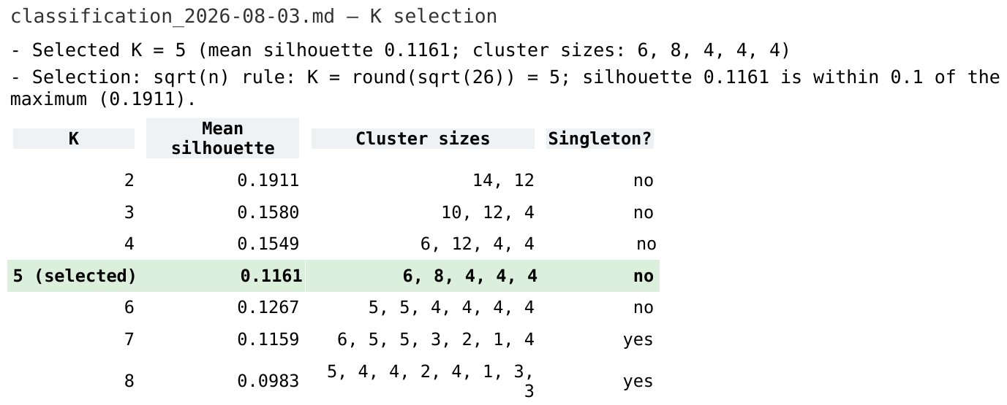
Excerpt from classification_2026-08-03.md: K selection and the silhouette-by-K table (green = selected).
1. Judge the strength before the membership. Mean silhouettes here run 0.10–0.19, which is weak-to-modest structure (values near 1 would indicate tight, well-separated clusters). These groupings are suggestive, not sharp. Note the rule’s trade-off in action: K = 2 has the best silhouette (0.1911), but the √n rule keeps K = 5 because 0.1161 is within the 0.1 tolerance; the K = 2 solution (14 vs. 12 texts) is stronger but less informative. The Silhouette-by-K table lets you make that call yourself — rerun with a fixed K to compare.
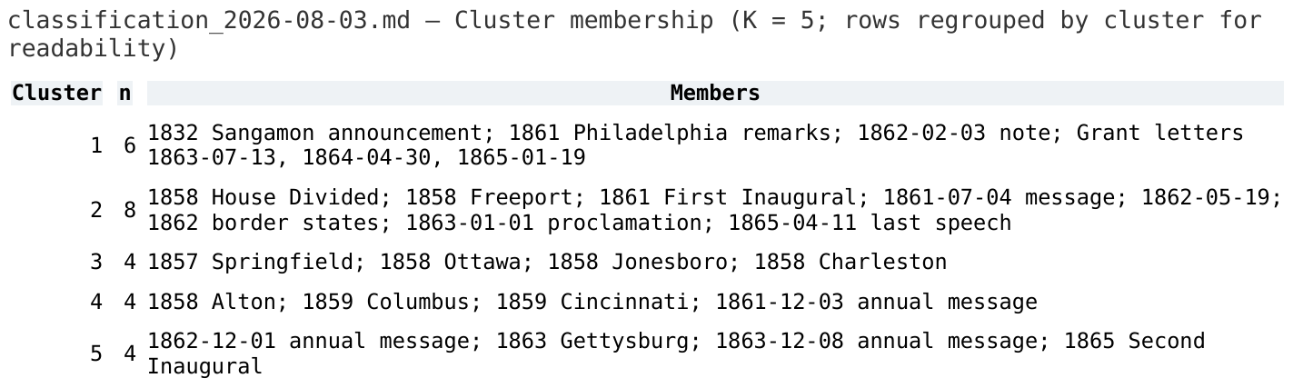
Membership summarized from classification_2026-08-03.md, regrouped by cluster (the report lists texts in load order).
2. Ask whether the clusters mean something. Recovered without any date or genre information, the clusters track both: cluster 3 is exactly the 1857–58 debate speeches, cluster 5 is the late-war canon (Gettysburg, the two late annual messages, the Second Inaugural), and cluster 4 pairs the 1859 Ohio speeches with Alton. Coherence against information the algorithm never saw is the best validity check available. But note cluster 1: it collects the shortest texts (the Grant letters, brief remarks). Tiny texts share near-zero resonance with everything, so they get grouped by sparsity rather than content. Treat that cluster as an artifact of size.
3. Cross-check with the dendrogram. The report’s default HAC cut (height 0.9855) yields K = 2 with sizes 25 and 1. The singleton is the 30-node 1865 Grant letter, the text least resonant with anything else. A top-of-dendrogram cut is doing outlier detection, not classification; drag the cut bar lower to expose the same debate/wartime groupings K-means finds. Where the two methods agree, trust the grouping more. Where they disagree, look at why before choosing one.

Reading the Theme Identifier output
The Theme Identifier runs PCA over the word-by-text influence matrix, then applies varimax rotation. Interpret in this order:
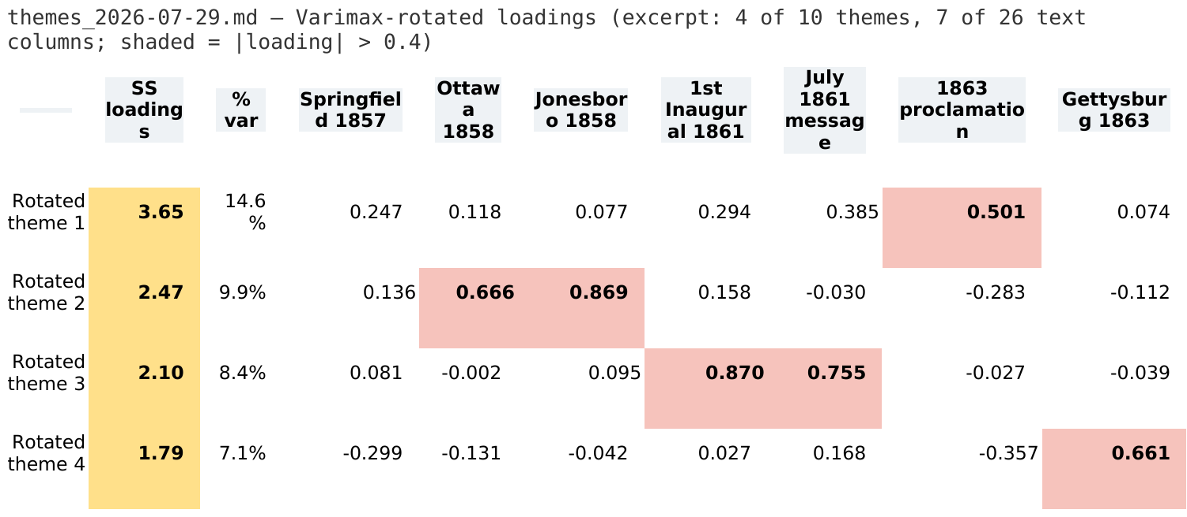
Excerpt from themes_2026-07-29.md: varimax-rotated loadings (4 of 10 themes, 7 of 26 texts); shading marks |loading| > 0.4.
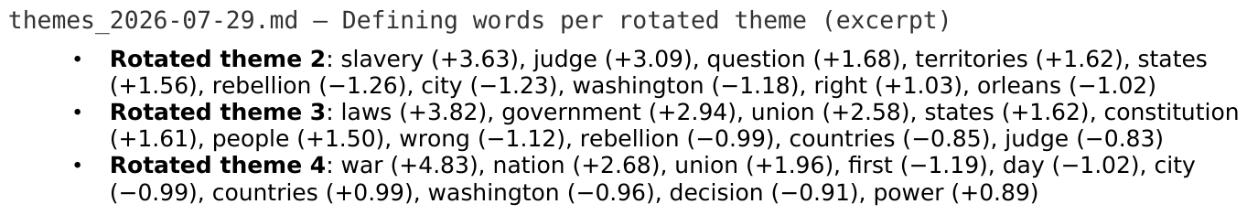
Excerpt from themes_2026-07-29.md: defining words per rotated theme (standardized word scores in z-units).
1. Eigenvalues first. In the Lincoln run, 10 of 26 components have eigenvalue > 1.0 (the Kaiser criterion, highlighted in the table); Theme 1 alone explains 19.3% of variance. Components below the criterion are usually noise and are best left uninterpreted.
2. Interpret the rotated solution, not the unrotated one. Unrotated components mix several patterns; rotation redistributes the variance so each text loads cleanly on few themes. In the Lincoln output, Rotated theme 2 loads heavily on the 1858 debate texts (Ottawa 0.67, Jonesboro 0.87, Charleston 0.74) and its defining words are slavery, judge, question, territories — a clean “Lincoln–Douglas debate” theme. Rotated theme 3 loads on the First Inaugural (0.87) and July 1861 message (0.76) with defining words laws, government, union, constitution — the constitutional-crisis theme. When the loadings and the defining words agree, the theme is interpretable. When they do not, leave it unresolved.
3. Keep loadings and word scores straight. Text loadings are correlations bounded by ±1.0 (highlighted when |loading| > 0.4). Defining-word scores are standardized component scores in z-units and can exceed 1 (e.g., states +6.2 on Rotated theme 1); they rank which words define a theme and are not loadings.
4. Heed the warnings. The run warns that one Grant letter has zero variance across the top-50 words (almost none of them appear in it), so its correlations are undefined and set to 0 — its zero loadings everywhere mean “could not be measured,” not “unrelated.”

Putting it together
A defensible reading of this corpus from the output alone: a stable structural core (states, people, nation) persists across 33 years; a sharply bounded 1858 debate cluster is organized around slavery, Douglas, and popular sovereignty; and after 1861 the structural vocabulary pivots to union, government, constitution, and war, with denser prose and lower first-person usage in the formal messages. Each of those claims traces to a specific table, and your own interpretations should meet the same standard. The software measures structure; building the interpretive argument, and standing behind it, is your job.

Appendix A. File Format Quick Reference

A.1 Tokenization file (.csv / .xlsx)
Two columns, no header. Column 1: text to find. Column 2: replacement. Example rows: “supply chain management, SCM”; “W. Edwards Deming, Deming”.

A.2 Latent codes file (.csv / .xlsx)
Two columns, no header. Column 1: theme name (repeat on multiple rows to add words). Column 2: one word, or several separated by commas. Example rows: “Sustainability, recycling”; “Sustainability, emissions, waste”; “Quality, defects”.

A.3 Outputs
File | Contents
filename_cra.md | The CRA network file: summary, influential words, text metrics, machine-readable data block.
crawdad-network-….png | Visualizer image, 1920×1080, slide-ready.
comparison_A_vs_B.md | Comparator report: four resonance values, common and unique word lists.
classification_….md | Classifier report: K-means membership, silhouette-by-K, resonance matrices, MDS coordinates, and the hierarchical-clustering cut set at download time.
themes_….md | Theme Identifier report: components, varimax solution, defining words, word-by-text matrix.
latent_themes_….md | Latent theme scores and coverage report.
summary_….md | Summarizer report: text profiles table and top-50 words.
crawdad-session-….zip | Session bundle of all loaded CRA files.

